

GoldHaven Defines District-Scale Structural Corridor at Magno Following Completion and Interpretation of Largest Modern Airborne Survey on the Project

Survey reveals continuous north-south magnetic corridor linking known tungsten, silver, zinc, copper and indium occurrences within a single district-scale geological framework — drill program with Northtech advancing toward August mobilization

Vancouver, British Columbia – July 15th, 2026 – GoldHaven Resources Corp. ("GoldHaven" or the "Company") (CSE: GOH) (OTCQB: GHVNF) (FSE: 4QS) is pleased to announce the successful completion and interpretation of its high-resolution airborne QMAGT magnetic survey over the Company's 100%-owned Magno Project in northern British Columbia.

Completed by Dias Geophysical, the survey comprised 2,320.7 line-kilometres flown at 100-metre line spacing, producing what GoldHaven believes is the most detailed modern airborne magnetic dataset collected across the Magno Project. Interpretation of the dataset has now been completed, defining a continuous district-scale structural corridor that links numerous known mineral occurrences while identifying multiple previously unrecognized exploration targets across the Company's 37,000+ hectare land package.

Why the Survey Matters

- Completed 2,320.7 line-kilometres of high-resolution airborne magnetic surveying at 100-metre line spacing.
- Largest modern airborne magnetic survey completed over the Magno Project.
- Defines a continuous north-south magnetic and structural corridor linking numerous known mineral occurrences within a common geological framework.
- Known occurrences within the corridor include surface values of up to 2,370 g/t Ag, 6,550 ppm W and 334 ppm In — one of the highest indium values ever recorded in the Cassiar District.
- Identifies multiple previously unrecognized magnetic anomalies, structural intersections and intrusive-related features across the property.
- Integrates airborne geophysics with geological mapping, historical drilling and surface geochemistry to substantially improve drill targeting.
- Northtech Drilling engaged for the Company's inaugural 5,000–7,000 metre drill program, with mobilization targeted for approximately August 1, 2026, subject to permitting.

CEO Commentary

"This survey represents a major technical milestone for the Magno Project. For the first time, we can see how the historic Kuhn tungsten skarns, the Magno and D Zone CRD system and the recently acquired Cassiar Moly target fit within a single regional structural framework.

The survey demonstrates that Magno is not a collection of isolated historical showings—it is one connected mineral system with coherent structural architecture that we can now systematically map, model and drill.

With Northtech advancing toward mobilization, this interpretation provides the strongest geological framework we've ever had for drill targeting across the property."

Rob Birmingham – President & CEO, GoldHaven Resources Corp.

The survey has significantly advanced GoldHaven's understanding of the district-scale geological architecture underlying the property. Interpretation of the data defines a continuous north-south magnetic and structural corridor that spatially correlates with numerous known occurrences of tungsten, silver, lead, zinc, copper and molybdenum mineralization. In addition, the survey has identified multiple previously unrecognized magnetic anomalies, structural intersections and intrusive-related magnetic features that significantly enhance the Company's ability to prioritize future drill targets.

The survey encompasses the Company's principal exploration areas, including the historic Kuhn and Dead Goat tungsten zones, the Magno and D Zone silver-lead-zinc targets, and the recently acquired Cassiar Moly target. For the first time, GoldHaven now has a consistent, property-wide geophysical framework linking these mineralized centres within a single regional geological setting.

The new airborne dataset provides GoldHaven with a consistent geological framework across more than 37,000 hectares of prospective ground. By integrating the magnetic data with historical drilling, surface geochemistry and geological mapping, the Company can more effectively prioritize drill targets, evaluate the relationship between known mineral occurrences and systematically explore areas that have seen little or no previous work.

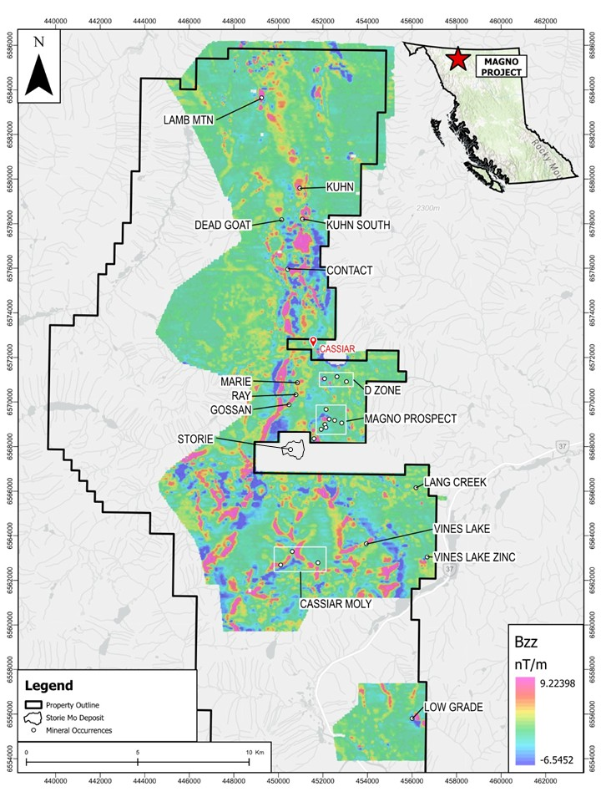

Figure 1. Bzz Vertical Magnetic Gradient map enhancing structural complexity across the Magno Project and identifying major lineaments, geological contacts and previously unrecognized exploration targets.

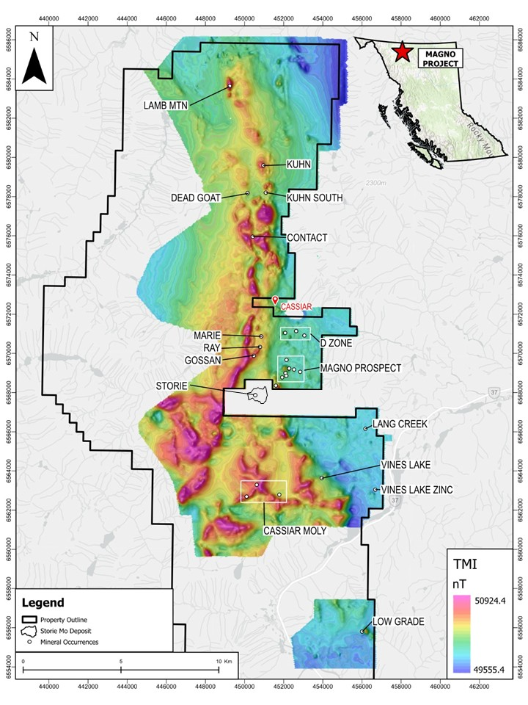

Figure 2. Total Magnetic Intensity (TMI) map outlining a continuous district-scale magnetic corridor extending across the Magno Project and linking numerous known mineral occurrences within a common geological framework.

Connecting the Mineral System

Prior to the airborne survey, Magno was interpreted largely as a collection of individual mineral prospects distributed across a large land package. Interpretation of the new magnetic dataset fundamentally changes that understanding.

The data defines a continuous north-south magnetic and structural corridor extending across much of the Company's 37,000+ hectare property. Historical occurrences of tungsten, silver, lead, zinc, copper, molybdenum and indium all occur within this common structural framework, suggesting they may represent expressions of a much larger mineralized system rather than isolated occurrences.

The vertical magnetic gradient product enhances structural resolution by clearly defining major geological contacts, lineaments and structural intersections. Many of these features have seen little or no historical exploration and represent priority targets for follow-up mapping, prospecting and drilling.

This regional perspective substantially improves GoldHaven's understanding of the geological controls on mineralization while providing a robust framework for systematic exploration across the project.

Historic Tungsten System Enhanced by New Geophysical Data

One of the most significant outcomes of the survey is the enhanced understanding of the Kuhn-Dead Goat tungsten corridor, where historical exploration outlined a historical estimate of approximately 616,500 tonnes grading 0.48% WO₃ across four modelled mineralized lenses. GoldHaven is not treating this historical estimate as a current mineral resource or mineral reserve but considers it highly relevant in guiding ongoing exploration and drill targeting.

Historical drilling within the Kuhn Zone intersected numerous high-grade tungsten-bearing skarn intervals, including:

- 13.0 metres grading 0.55% WO₃
- 11.3 metres grading 0.59% WO₃ and 0.10% MoS₂
- 6.0 metres grading 0.58% WO₃
- 4.4 metres grading 0.75% WO₃ and 0.17% Cu
- 4.0 metres grading 1.32% WO₃ and 0.26% MoS₂

A Qualified Person has not completed sufficient work to classify the historical estimate as a current mineral resource or mineral reserve, and GoldHaven is not treating the historical estimate as a current mineral resource or mineral reserve. The historical estimate is considered relevant to investors as it demonstrates the presence of a significant tungsten-bearing system and assists in guiding exploration and drill targeting.

The new airborne magnetic survey demonstrates that the historic Kuhn-Dead Goat tungsten system is situated within a much larger regional structural framework extending across the Magno Project. This significantly improves GoldHaven's understanding of the geological setting surrounding the historical tungsten mineralization while providing a stronger technical basis for evaluating extensions of the system and identifying additional drill targets.

Indium and Critical Mineral Context

Beyond tungsten, the Magno Project has returned surface indium values of up to 334 ppm, representing the highest indium values reported in the Cassiar District. Both indium and tungsten are recognized as critical minerals by Canada and the United States due to their importance in advanced manufacturing, defence technologies and semiconductor supply chains.

The identification of both metals within the same district-scale structural corridor further enhances the strategic significance of the Magno Project and supports continued systematic exploration of the broader mineral system.

Next Steps

- Drill program mobilization: Northtech Drilling engaged for an inaugural 5,000–7,000-metre diamond drill program. Mobilization targeted for approximately August 1, 2026, subject to receipt of final exploration permits.
- Priority target integration: Airborne magnetic data integrated with geological mapping, historical drilling and surface geochemistry to finalize drill collar locations across the Kuhn tungsten corridor, Magno and D Zone silver-zinc CRD targets, and QMAGT-generated intrusive targets.
- Storie and Cassiar Moly follow-up: Prospecting and geochemical follow-up planned on the Storie molybdenum occurrence and Cassiar Moly target, now confirmed within the district-scale magnetic corridor.
- Permitting advancement: Final exploration permit applications advancing in parallel with drill target finalization.
- Technical updates: Interpreted QMAGT products, geological map updates and drill target summaries to be provided as they are finalized.

Qualified Person:

The technical and scientific information contained in this news release has been reviewed and approved by Raymond Wladichuk, P.Geo. who is a non-independent Qualified Person as defined under NI 43-101 and a consultant of the Company.

Marketing Agreements

Further to the Company’s press release of July 7, 2026, the representatives of Gold Standard Media LLC are Kenneth Ameduri (CEO),Juliet Ameduri and Lior Gantz (authorized representatives) with the following contact information: 723 W University Ave., Suite 123-283, Georgetown TX, 78626; +1(619) 354-1015; ceo@goldstandardir.com.

Further to the Company’s press release of July 2, 2026, the representative of X Media Inc SEZC is Melissa Destarac (CEO) with the following contact information: 2nd Floor, Strathvale House, 90 North Church Street, KY1-1102 George Town, Grand Cayman; +1(502) 369-1458; admin@x-publishing.com.‬

About GoldHaven Resources Corp.

GoldHaven Resources Corp. is a Canadian junior exploration company focused on advancing highly prospective mineral projects in North and South America. The Company’s flagship asset is the district-scale Magno Project in the Cassiar District of northern British Columbia. GoldHaven also owns the Three Guardsmen copper-gold project in British Columbia and the Copeçal Gold Project in Mato Grosso, Brazil. In addition, the Company holds a portfolio of critical mineral projects in Brazil.

On Behalf of the Board of Directors

Rob Birmingham, Chief Executive Officer

For further information, please contact:
Rob Birmingham, CEO
www.GoldHavenresources.com
info@goldhavenresources.com
Office Direct: (604) 629-8254

Neither the CSE nor its Regulation Services Provider (as that term is defined in the policies of the CSE- Canadian Securities Exchange) accepts responsibility for the adequacy or accuracy of this release.

Cautionary Statements Regarding Forward Looking Information

This news release contains forward-looking statements and forward-looking information (collectively, "forward looking statements") within the meaning of applicable Canadian and U.S. securities legislation, including the United States Private Securities Litigation Reform Act of 1995. All statements, other than statements of historical fact, included herein including, without limitation, those listed below under the heading “Forward-Looking Statements in This News Release” are forward-looking statements. Although the Company believes that such statements are reasonable, it can give no assurance that such expectations will prove to be correct. Forward-looking statements are typically identified by words such as: "believes", "will", "expects", "anticipates", "intends", "estimates", "plans", "may", "should", "potential", "scheduled", or variations of such words and phrases and similar expressions, which, by their nature, refer to future events or results that may, could, would, might or will occur or be taken or achieved. In making the forward-looking statements in this news release, the Company has applied several material assumptions, including without limitation, that there will be investor interest in future financings, market fundamentals will result in sustained precious metals demand and prices, the receipt of any necessary permits, licenses and regulatory approvals in connection with the future exploration and development of any future projects in a timely manner, the availability of financing on suitable terms for exploration and development of future projects and the Company's ability to comply with environmental, health and safety laws.

The Company cautions investors that any forward-looking statements by the Company are not guarantees of future results or performance, and that actual results may differ materially from those in forward-looking statements as a result of various factors, including, operating and technical difficulties in connection with mineral exploration and development activities, actual results of exploration activities, the estimation or realization of mineral reserves and mineral resources, the inability of the Company to obtain the necessary financing required to conduct its business and affairs, as currently contemplated, the inability of the Company to enter into definitive agreements in respect of possible Letters of Intent, the timing and amount of estimated future production, the costs of production, capital expenditures, the costs and timing of the development of new deposits, requirements for additional capital, future prices of precious metals, changes in general economic conditions, changes in the financial markets and in the demand and market price for commodities, lack of investor interest in future financings, accidents, labour disputes and other risks of the mining industry, delays in obtaining governmental approvals, permits or financing or in the completion of development or construction activities, changes in laws, regulations and policies affecting mining operations, title disputes, the inability of the Company to obtain any necessary permits, consents, approvals or authorizations, including by the Exchange, the timing and possible outcome of any pending litigation, environmental issues and liabilities, and risks related to joint venture operations, and other risks and uncertainties disclosed in the Company's latest interim Management's Discussion and Analysis and filed with certain securities commissions in Canada. All of the Company's Canadian public disclosure filings may be accessed via www.sedarplus.ca and readers are urged to review these materials.

Readers are cautioned not to place undue reliance on forward-looking statements. The Company undertakes no obligation to update any of the forward-looking statements in this news release or incorporated by reference herein, except as otherwise required by law.

Forward-Looking Statements in This News Release

The following statements in this news release constitute forward-looking information:
• Northtech Drilling's inaugural 5,000–7,000 metre diamond drill program is targeted to mobilize on or about August 1, 2026, subject to receipt of final exploration permits;
• airborne magnetic data will be integrated with geological mapping, historical drilling and surface geochemistry to finalize drill collar locations across the Kuhn tungsten corridor, the Magno and D Zone silver-zinc CRD targets, and QMAGT-generated intrusive targets;
• prospecting and geochemical follow-up is planned on the Storie molybdenum occurrence and the Cassiar Moly target;
• final exploration permit applications are advancing in parallel with drill target finalization;
• interpreted QMAGT products, geological map updates and drill target summaries will be provided as they are finalized; and
• management's belief that the airborne survey interpretation provides the strongest geological framework the Company has had for drill targeting across the Magno Project.

