

GoldHaven Advances Porphyry Copper Target at Three Guardsmen
Program designed to identify the potential source of previously reported high-grade copper mineralization grading up to 15.85% Cu
Vancouver, British Columbia – July 22nd, 2026 – GoldHaven Resources Corp. ("GoldHaven" or the "Company") (CSE: GOH) (OTCQB: GHVNF) (FSE: 4QS) is pleased to announce the successful completion of its 2026 induced polarization ("IP") geophysical survey and geological field program at its 100%-owned Three Guardsmen Project in southwestern Yukon.
The program represents another important milestone in GoldHaven's systematic exploration of an emerging porphyry copper system and was specifically designed to identify the potential intrusive source believed to have generated the magnetite-copper skarn, previously identified across the property.

Highlights
- Advances GoldHaven's emerging porphyry copper target following previously reported high-grade copper samples of up to 15.85% Cu
- Completed approximately 3.9 kilometres of targeted induced polarization ("IP") surveying designed to identify the potential intrusive source of previously identified magnetite-copper skarn mineralization.
- Geological mapping identified a broad oxidized gossan zone associated with altered intrusive rocks, further supporting the Company's evolving geological interpretation.
- Geophysical inversion and interpretation are underway, with results to be integrated into the Company's drill targeting strategy.
The program follows GoldHaven's successful 2025 exploration campaign, during which the Company identified numerous high-grade magnetite-copper skarn occurrences, including grab
samples grading 15.85% copper, 12.75% copper and 12.65% copper, with 25 grab samples returning greater than 1% copper.
CEO Commentary:
"Three Guardsmen continues to strengthen our confidence that we are vectoring toward a much larger mineralized system than originally recognized," commented Rob Birmingham, President & CEO of GoldHaven. "This year's program was specifically designed to identify the intrusive source that may have generated the previously identified magnetite-copper skarn mineralization. The completion of this work, combined with encouraging geological observations in the field, provides another important dataset as we continue advancing one of our most prospective copper projects."

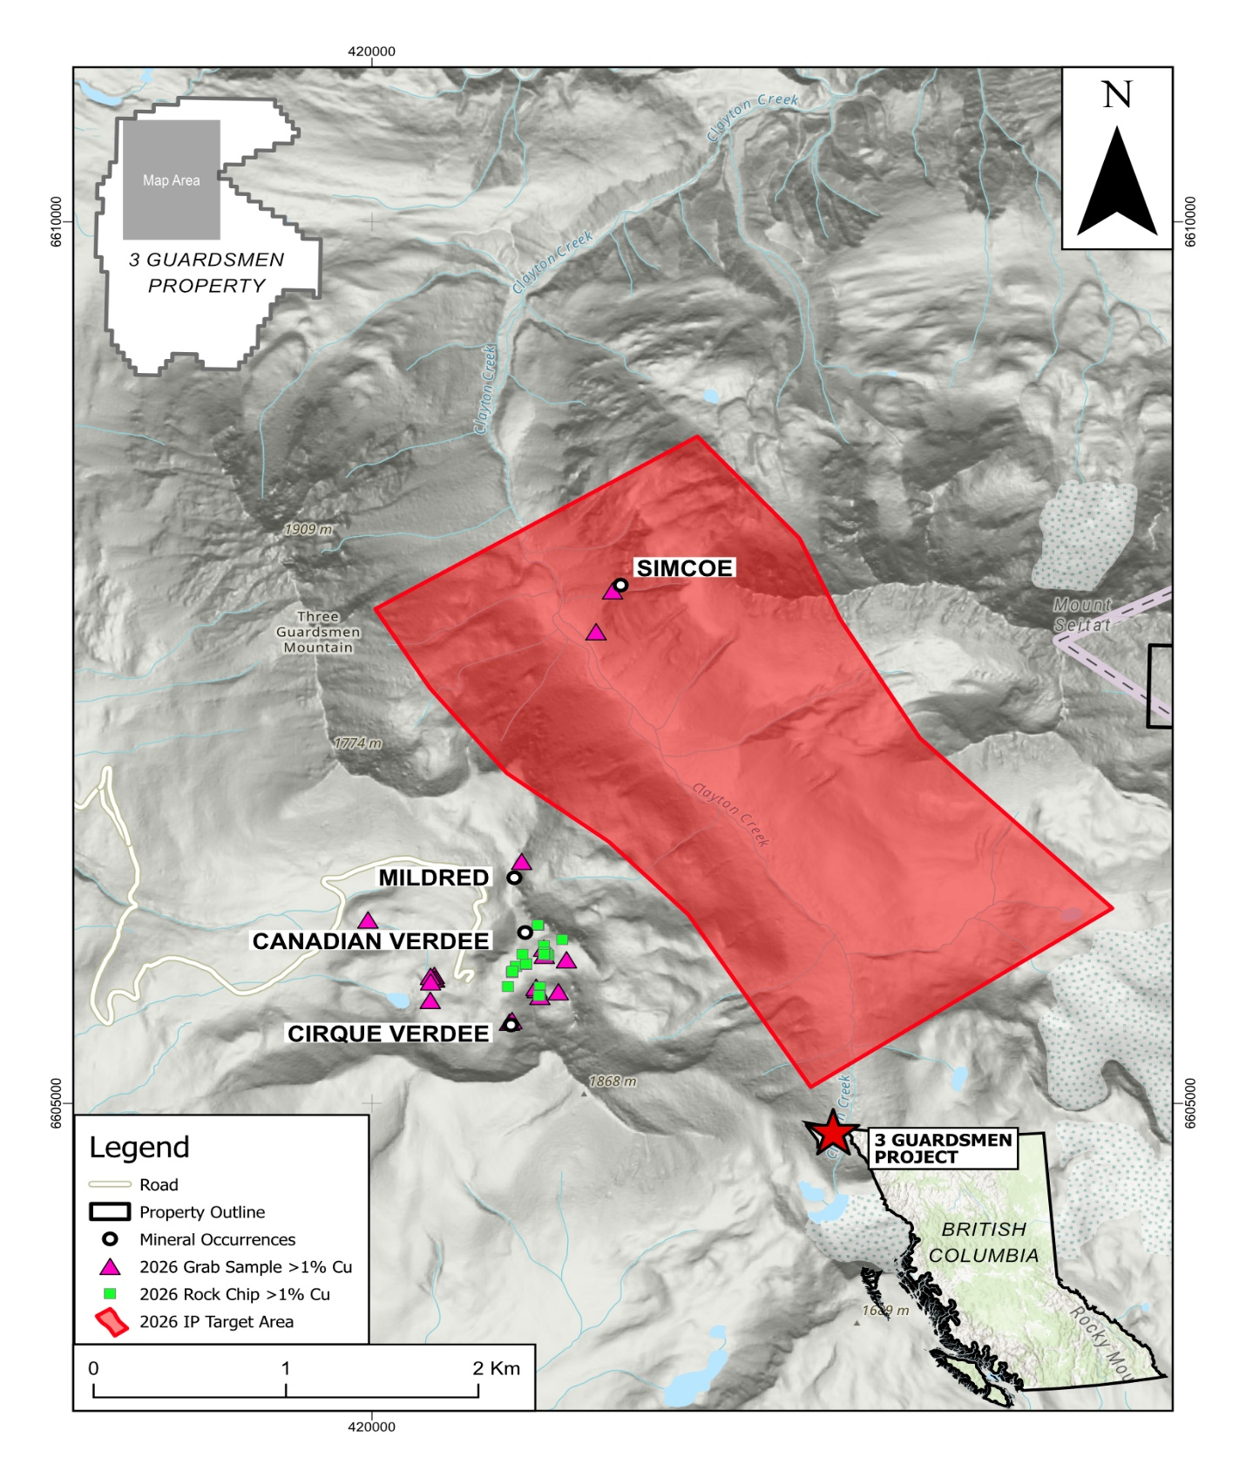
Figure 1. Location of the completed 2026 induced polarization survey lines relative to previously reported high-grade copper occurrences and priority exploration targets at the Three Guardsmen Project.

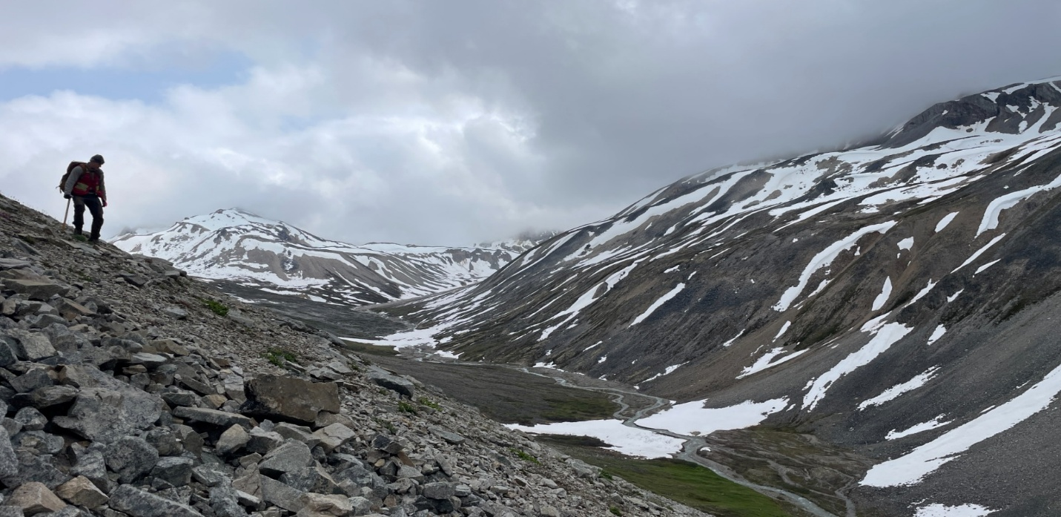
Figure 2. View looking south across the primary exploration valley at the Three Guardsmen Project, Yukon, where the 2026 induced polarization ("IP") survey and geological mapping program were completed.
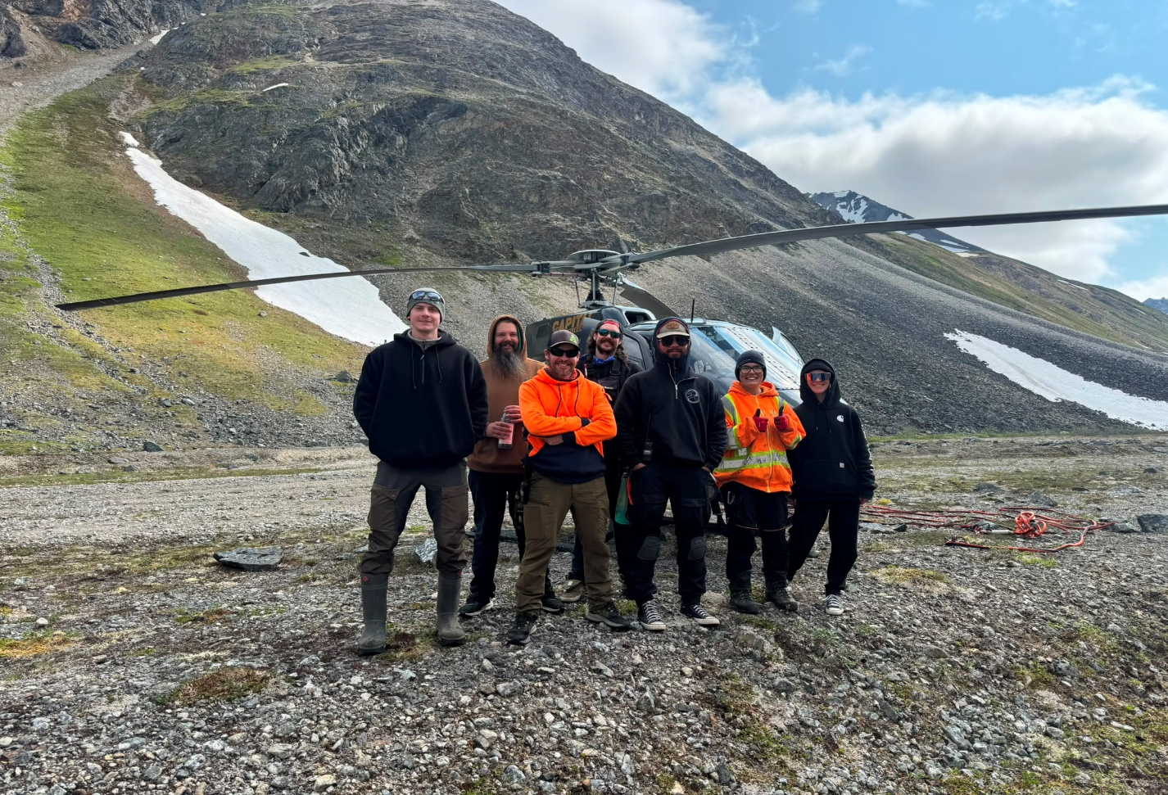
Figure 3. GoldHaven geological team Scott Geophysics, and Capital Helicopters personnel following completion of the 2026 IP survey at the Three Guardsmen Project.

Targeting the Source of the Copper System
The program consisted of approximately 3.9 kilometres of induced polarization surveying completed over three strategically positioned survey lines designed to test the Company's interpretation of a northwest-trending mineralized corridor. The survey was planned to evaluate whether previously identified high-grade copper-bearing skarn mineralization is associated with a larger concealed intrusive system.
Concurrent geological mapping focused on identifying hydrothermal alteration, intrusive relationships and structural controls capable of vectoring toward the centre of the mineralizing system.
The 2026 field program was completed between July 6 and July 17 utilizing helicopter-supported exploration crews, with helicopter services provided by Capital Helicopters, enabling efficient access to remote target areas across the property.
During the program, the geological team documented widespread alteration within granitic host rocks and adjacent magnetite-bearing copper skarn occurrences. Visible sulphide mineralization observed in the field included pyrite, chalcopyrite, pyrrhotite and locally molybdenite, further supporting the interpreted porphyry-skarn exploration model. The presence of magnetite-rich copper skarn mineralization is considered particularly encouraging, as this style of mineralization is commonly associated with calc-alkaline porphyry systems and occurs in significant British Columbia copper districts, including the Island Copper district. While no inference is made that mineralization at Three Guardsmen is comparable in size, grade or economic significance, these geological characteristics further support the Company's exploration model targeting a concealed porphyry source.
The field team also identified a broad oxidized gossan exposure within the southeastern portion of the target valley. The gossan appears spatially associated with altered intrusive rocks and further supports the Company's interpretation of a northwest-trending mineralized corridor. Portions of this target remained inaccessible due to persistent seasonal snow cover, limiting direct examination and making the area a priority target for future exploration.

Next Steps
The completed geophysical dataset has been submitted for processing and three-dimensional inversion.
Upon completion, GoldHaven will integrate the interpreted geophysical results with geological mapping, geochemistry and structural data to identify chargeability and resistivity anomalies that may represent priority drill targets.
The Company expects the interpreted geophysical results will further refine its understanding of the Three Guardsmen mineral system and assist in prioritizing future drilling and follow-up exploration.

About the Three Guardsmen Project
The Three Guardsmen Project comprises approximately 16,234 hectares in southwestern Yukon and is prospective for copper-gold skarn and porphyry-style mineralization. Exploration completed to date has identified numerous copper-bearing skarn occurrences distributed across the property.

GoldHaven believes these mineralized occurrences may represent the distal expression of a larger mineralizing system concealed beneath the project area.
Historical Sampling QA/QC
The historical rock sample results referenced in this news release were previously disclosed in the Company's news release dated December 9th, 2025. Details regarding sampling procedures, quality assurance and quality control protocols, analytical methods, laboratory information and Qualified Person disclosure are contained in that news release.

Cautionary Statement Regarding Grab Samples
The historical grab sample results referenced in this news release are selective in nature and may not be representative of the mineralization present on the property. Readers are cautioned not to place undue reliance on grab sample results.

Qualified Person:
The scientific and technical information contained in this news release has been reviewed and approved by Raymond Wladichuk, P.Geo., a non-independent Qualified Person as defined by National Instrument 43-101 and a consultant to the Company.

About GoldHaven Resources Corp.

GoldHaven Resources Corp. is a Canadian junior exploration company focused on advancing highly prospective mineral projects in North and South America. The Company’s flagship asset is the district-scale Magno Project in the Cassiar District of northern British Columbia. GoldHaven also owns the Three Guardsmen copper-gold project in British Columbia and the Copeçal Gold Project in Mato Grosso, Brazil. In addition, the Company holds a portfolio of critical mineral projects in Brazil.

On Behalf of the Board of Directors

Rob Birmingham, Chief Executive Officer

For further information, please contact:
Rob Birmingham, CEO
www.GoldHavenresources.com
info@goldhavenresources.com
Office Direct: (604) 629-8254

Neither the CSE nor its Regulation Services Provider (as that term is defined in the policies of the CSE- Canadian Securities Exchange) accepts responsibility for the adequacy or accuracy of this release.

Cautionary Statements Regarding Forward Looking Information

This news release contains forward-looking statements and forward-looking information (collectively, "forward looking statements") within the meaning of applicable Canadian and U.S. securities legislation, including the

United States Private Securities Litigation Reform Act of 1995. All statements, other than statements of historical fact, included herein including, without limitation, those listed below under the heading “Forward-Looking Statements in This News Release” are forward-looking statements. Although the Company believes that such statements are reasonable, it can give no assurance that such expectations will prove to be correct. Forward-looking statements are typically identified by words such as: "believes", "will", "expects", "anticipates", "intends", "estimates", "plans", "may", "should", "potential", "scheduled", or variations of such words and phrases and similar expressions, which, by their nature, refer to future events or results that may, could, would, might or will occur or be taken or achieved. In making the forward-looking statements in this news release, the Company has applied several material assumptions, including without limitation, that there will be investor interest in future financings, market fundamentals will result in sustained precious metals demand and prices, the receipt of any necessary permits, licenses and regulatory approvals in connection with the future exploration and development of any future projects in a timely manner, the availability of financing on suitable terms for exploration and development of future projects and the Company's ability to comply with environmental, health and safety laws.

The Company cautions investors that any forward-looking statements by the Company are not guarantees of future results or performance, and that actual results may differ materially from those in forward-looking statements as a result of various factors, including, operating and technical difficulties in connection with mineral exploration and development activities, actual results of exploration activities, the estimation or realization of mineral reserves and mineral resources, the inability of the Company to obtain the necessary financing required to conduct its business and affairs, as currently contemplated, the inability of the Company to enter into definitive agreements in respect of possible Letters of Intent, the timing and amount of estimated future production, the costs of production, capital expenditures, the costs and timing of the development of new deposits, requirements for additional capital, future prices of precious metals, changes in general economic conditions, changes in the financial markets and in the demand and market price for commodities, lack of investor interest in future financings, accidents, labour disputes and other risks of the mining industry, delays in obtaining governmental approvals, permits or financing or in the completion of development or construction activities, changes in laws, regulations and policies affecting mining operations, title disputes, the inability of the Company to obtain any necessary permits, consents, approvals or authorizations, including by the Exchange, the timing and possible outcome of any pending litigation, environmental issues and liabilities, and risks related to joint venture operations, and other risks and uncertainties disclosed in the Company's latest interim Management's Discussion and Analysis and filed with certain securities commissions in Canada. All of the Company's Canadian public disclosure filings may be accessed via www.sedarplus.ca and readers are urged to review these materials.

Readers are cautioned not to place undue reliance on forward-looking statements. The Company undertakes no obligation to update any of the forward-looking statements in this news release or incorporated by reference herein, except as otherwise required by law.

Forward-Looking Statements in This News Release

The following statements in this news release constitute forward-looking information:
- the integration of geophysical inversion results into the Company's drill targeting strategy;
- the integration of interpreted geophysical results with geological mapping, geochemistry and structural data to identify priority drill targets;
- the expectation that the interpreted geophysical results will refine the Company's understanding of the Three Guardsmen mineral system and assist in prioritizing future drilling and follow-up exploration;
- the potential for mineralized occurrences at Three Guardsmen to represent the distal expression of a larger mineralizing system concealed beneath the project area; and
- plans to prioritize further exploration of the previously inaccessible gossan target area.

