

GOLDHAVEN ADVANCES TUNGSTEN DRILLING AT MAGNO PROJECT, BRITISH COLUMBIA
Maiden drill program advancing at the historic Kuhn tungsten system, with drilling encountering broad skarn intervals
VANCOUVER, British Columbia, September 15, 2026 – GoldHaven Resources Corp. (“GoldHaven” or the “Company”) (CSE: GOH) (OTCQB: GHVNF) (FSE: 4QS) is pleased to provide an update on its ongoing maiden diamond drill program at the 100%-owned Magno Project, located in the Cassiar District of northern British Columbia.
- Over 800 metres drilled from the first drill pad at the historic Kuhn tungsten system, with drilling continuing across multiple planned drill fences.
- Initial drilling encountered an approximately 20-metre interval of skarn, where historical interpretation had mapped two separate narrower skarn bands.
- Historic drilling at Kuhn returned strong tungsten intercepts, including 13.0 m grading 0.55% WO₃ and 11.3 m grading 0.59% WO₃ + 0.10% MoS₂.*
- Historical work outlined approximately 616,500 tonnes grading 0.48% WO₃ across four modeled lenses at the Kuhn–Dead Goat system.*
- Current drilling is targeting the geometry and continuity of the tungsten-bearing skarn, while testing potential extensions beyond historically drilled areas.
Historical results and estimates pre-date NI 43-101 and are subject to the applicable cautionary language provided in this release.
Diamond drilling commenced in late August at the historic Kuhn tungsten skarn system, with over 800 metres of drilling completed to date in four (4) drill holes from the first drill pad (Pad A). The initial phase of drilling is designed to test the geometry, continuity and potential extensions of the historically identified tungsten-bearing skarn mineralization while providing the first modern drill data.
Drilling in the first three drill holes has encountered broad intervals of skarn alteration and sulphide mineralization within the top 100m, including an approximately 20-metre interval of skarn in the second drill hole. This interval is particularly notable because the historical geological interpretation at this site was mapped as two separate skarn bands, whereas initial observations from the current drilling suggest the possibility of a broader, more continuous skarn package. The fourth drill hole (GOH26-04) has confirmed a never before explored down-dip extension of the skarn unit.

Visually, the geology encountered in the first drill holes appears to match the lithological descriptions described in the historical drill logs and reports. Further, analysis with a portable XRF indicates the presence of tungsten within the skarn intersections.
Rob Birmingham, CEO of GoldHaven, commented:
“The first phase of drilling at Magno is doing exactly what we wanted it to do – giving us a modern look at a historically important tungsten system that has seen very limited exploration for decades. We are encouraged by the scale of the skarn alteration encountered in the early holes, particularly where drilling appears to show a broader package than suggested by the historical interpretation. With drilling continuing, our priority is to systematically test Kuhn and build the geological framework needed to determine the scale and continuity of the system.”

Kuhn Drilling Update
The current drilling is focused on systematically testing the historic Kuhn tungsten system through a series of drill fences designed to provide greater geological control across the mineralized trend.
The four initial drill holes from Pad A are designed to test the system at greater depth and evaluate potential extensions. Following completion of the first pad, the drill is planned to advance to a second drill pad along strike where approximately three to four additional holes are planned.
The Company’s objective during this phase is to establish multiple modern drill sections across Kuhn, providing significantly improved information on the geometry, thickness and continuity of the skarn system and allowing direct comparison with historical drilling.
Drilling remains ongoing at Kuhn, with results from the current program being integrated with historical drilling, surface geology and modern geophysical data to guide subsequent drill targeting. Results from the current program, together with historical drilling, surface geology and modern geophysical data, will be used to determine whether additional drilling is warranted at Kuhn before the program advances to other priority targets within the Magno property.

Historic Kuhn Tungsten System
The Kuhn–Dead Goat area hosts a series of historically defined tungsten-bearing skarn lenses. Historical work outlined an estimate of approximately 616,500 tonnes grading 0.48% WO₃ across four modeled lenses.
Historical drilling at Kuhn included reported intersections of:
- 13.0 metres grading 0.55% WO₃
- 11.3 metres grading 0.59% WO₃ and 0.10% MoS₂
- 4.0 metres grading 1.32% WO₃ and 0.26% MoS₂
The historical estimate and drill results pre-date NI 43-101 and should not be considered a current mineral resource or mineral reserve. A Qualified Person has not completed sufficient work to

classify the historical estimate as a current mineral resource, and GoldHaven is not treating the historical estimate as a current mineral resource.
The current program represents an important step toward establishing modern geological and analytical data across the Kuhn system and evaluating the continuity and potential extensions of the historically identified tungsten mineralization.
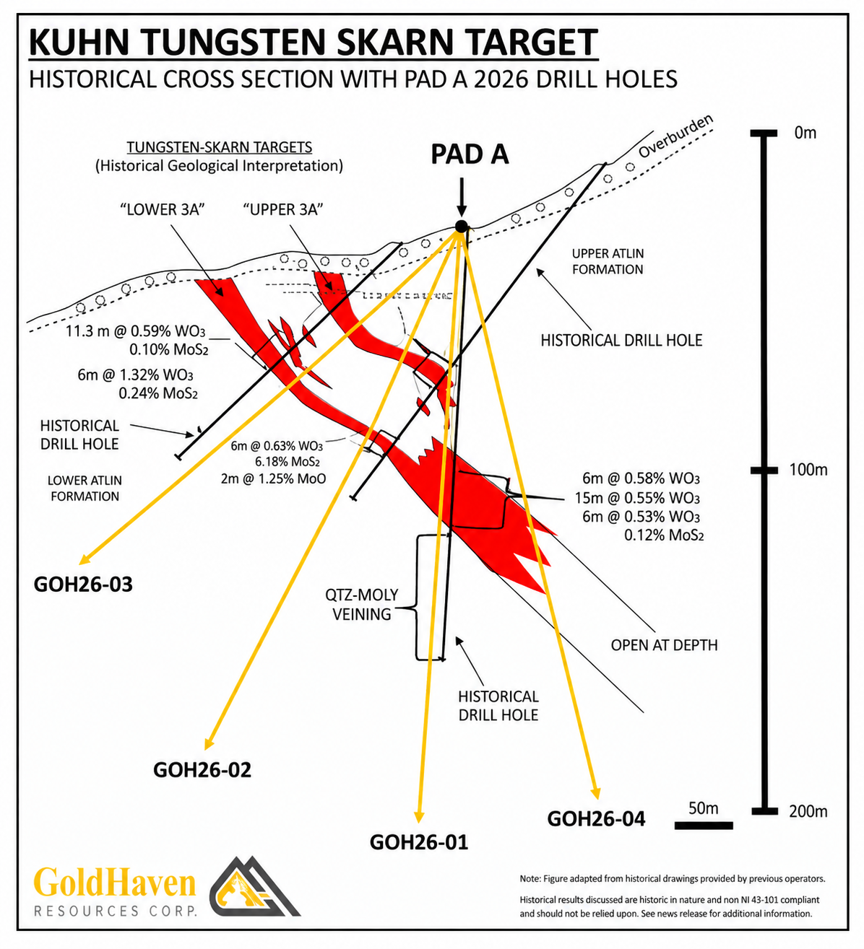
Figure 1. Kuhn Tungsten Skarn Target – Historical Cross Section and 2026 Drill Testing. Historical geological interpretation of the Kuhn tungsten-skarn system showing historical drilling and mineralized skarn lenses, together with GoldHaven’s four 2026 drill holes from Pad A.
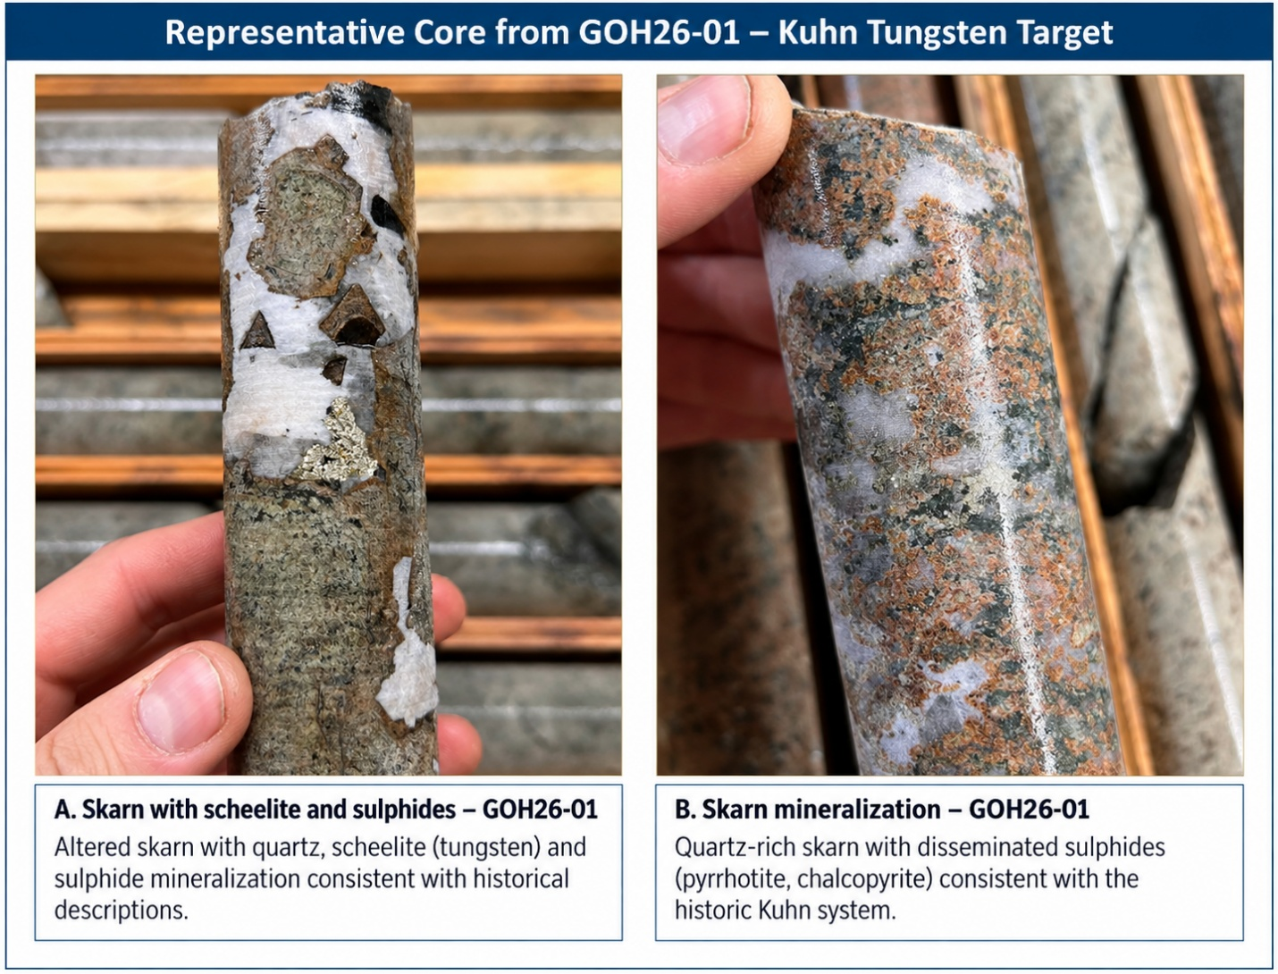

Figure 2. Representative drill core from GOH26-01 at the Kuhn tungsten target, showing skarn alteration, quartz veining and sulphide mineralization. Assays are pending.

Broader Magno Drill Program
Kuhn represents the first phase of a broader drill campaign across the district-scale 37,000+ hectare Magno Project.
Following the initial Kuhn program, GoldHaven intends to evaluate additional high-priority drill targets, including the D Zone and broader Magno target area, where historical exploration and recent surface work have identified significant silver, lead, zinc, gold and copper mineralization.
Drill targeting across Magno is being supported by the integration of historical drilling and underground workings, surface mapping and geochemistry, and GoldHaven’s recently completed 2,320.7 line-kilometre airborne magnetic and QMAGT survey. The Company continues to integrate these datasets as drilling progresses and new geological information becomes available.
The 2026 program is being completed by Northtech Drilling and represents the first modern, systematic drill campaign undertaken by GoldHaven at Magno.


Figure 3. Diamond drilling underway at the Kuhn tungsten target, Magno Project, northern British Columbia.

Next Steps
Drilling remains ongoing at Kuhn, with the immediate program focused on completing the planned drill fences and evaluating the continuity of the skarn system. Core is being logged, sampled and submitted for laboratory analysis, with assay results to be released as they are received, reviewed and verified.
The Company will use the geological observations and analytical results from the initial Kuhn drilling to refine subsequent drill targeting both at Kuhn and across the broader Magno Project.

Qualified Person:
The technical and scientific information contained in this news release has been reviewed and approved by Raymond Wladichuk P.Geo. who is a non-independent Qualified Person as defined under NI 43-101 and a consultant of the Company.

About GoldHaven Resources Corp.

GoldHaven Resources Corp. is a Canadian junior exploration company focused on advancing highly prospective mineral projects in North and South America. The Company’s flagship asset is the district-scale Magno Project in the Cassiar District of northern British Columbia. GoldHaven also owns the Three Guardsmen copper-gold project in British Columbia and the Copeçal Gold Project in Mato Grosso, Brazil. In addition, the Company holds a portfolio of critical mineral projects in Brazil.

On Behalf of the Board of Directors

Rob Birmingham, Chief Executive Officer

For further information, please contact:
Rob Birmingham, CEO
www.GoldHavenresources.com
info@goldhavenresources.com
Office Direct: (604) 629-8254

Neither the CSE nor its Regulation Services Provider (as that term is defined in the policies of the CSE- Canadian Securities Exchange) accepts responsibility for the adequacy or accuracy of this release.

Cautionary Statements Regarding Forward Looking Information

This news release contains forward-looking statements and forward-looking information (collectively, "forward looking statements") within the meaning of applicable Canadian and U.S. securities legislation, including the United States Private Securities Litigation Reform Act of 1995. All statements, other than statements of historical fact, included herein including, without limitation, those listed below under the heading “Forward-Looking Statements in This News Release” are forward-looking statements. Although the Company believes that such statements are reasonable, it can give no assurance that such expectations will prove to be correct. Forward-looking statements are typically identified by words such as: "believes", "will", "expects", "anticipates", "intends", "estimates", "plans", "may", "should", "potential", "scheduled", or variations of such words and phrases and similar expressions, which, by their nature, refer to future events or results that may, could, would, might or will occur or be taken or achieved. In making the forward-looking statements in this news release, the Company has applied several material assumptions, including without limitation, that there will be investor interest in future financings, market fundamentals will result in sustained precious metals demand and prices, the receipt of any necessary permits, licenses and regulatory approvals in connection with the future exploration and development of any future projects in a timely manner, the availability of financing on suitable terms for exploration and development of future projects and the Company's ability to comply with environmental, health and safety laws.

The Company cautions investors that any forward-looking statements by the Company are not guarantees of future results or performance, and that actual results may differ materially from those in forward-looking statements as a result of various factors, including, operating and technical difficulties in connection with mineral exploration and development activities, actual results of exploration activities, the estimation or realization of mineral reserves and mineral resources, the inability of the Company to obtain the necessary financing required to conduct its business and affairs, as currently contemplated, the inability of the Company to enter into definitive agreements in respect of possible Letters of Intent, the timing and amount of estimated future production, the costs of production, capital expenditures, the costs and timing of the development of new deposits, requirements for additional capital, future prices of precious metals, changes in general economic conditions, changes in the financial markets and in the demand and market price for commodities, lack of investor interest in future financings, accidents, labour disputes and other risks of the mining industry, delays in obtaining governmental approvals, permits or financing or in the completion of development or construction activities, changes in laws, regulations and policies affecting mining operations, title disputes, the inability of the Company to obtain any necessary permits, consents, approvals or authorizations, including by the Exchange, the timing and possible outcome of any pending litigation, environmental issues and liabilities, and risks related to joint venture operations, and other risks and uncertainties disclosed in the Company's latest interim Management's Discussion and Analysis and filed with certain securities commissions in Canada. All of the Company's Canadian public disclosure filings may be accessed via www.sedarplus.ca and readers are urged to review these materials.

Readers are cautioned not to place undue reliance on forward-looking statements. The Company undertakes no obligation to update any of the forward-looking statements in this news release or incorporated by reference herein, except as otherwise required by law.

Forward-Looking Statements in This News Release

The following statements in this news release constitute forward-looking information:
- the Company's plans to complete the planned drill fences at the Kuhn tungsten system and to advance the drill program to a second drill pad along strike, where approximately three to four additional holes are planned;
- GoldHaven's intention, following completion of the initial Kuhn program, to evaluate additional high-priority drill targets across the Magno Project, including the D Zone and broader Magno target area;
- expectations regarding the timing of release of assay results from the current drill program as they are received, reviewed and verified;
- the Company's plans to use geological observations and analytical results from the initial Kuhn drilling to refine subsequent drill targeting both at Kuhn and across the broader Magno Project, and to determine whether additional drilling is warranted at Kuhn before the program advances to other priority targets; and
- the potential for extensions of the tungsten-bearing skarn mineralization at Kuhn beyond the areas that have been historically drilled.

